# **Monthly Meeting #6:** Full Group **Meeting**

| **Meeting Date:** | Sep 14, 2023 | |
| --- | --- | --- |
| Meeting Time: | 6pm ET | |
| Meeting Location: | Virtual | |
| Meeting Type: | Full Group Meeting | |
| Student Team Members: *(check box if in attendance)* | * Rachel * Vanessa * Kashish * Pamela * Elena * Nyah | |
| Other Attendees:  *(e.g., Challenge Advisor, TA)* | Maria, Keith | |

# HELPFUL LINKS

* [GitHub problem description](https://github.com/mathworks/MATLAB-Simulink-Challenge-Project-Hub/tree/main/projects/Classify%20Object%20Behavior%20to%20Enhance%20the%20Safety%20of%20Autonomous%20Vehicles)
* [Automated Driving Toolbox](https://www.mathworks.com/products/automated-driving.html)
* [nuScenes](https://www.nuscenes.org/)
* [nuScenes prediction tutorial](https://github.com/nutonomy/nuscenes-devkit/blob/master/python-sdk/tutorials/prediction_tutorial.ipynb)
* [Project Scope and Deliverables_Fall 2023 AI Studio](https://docs.google.com/document/d/1XCItxeW-T5N9MZTvkZkYsv8ASGEQY1nxX9xmxmBHbW4/edit?usp=drive_link)
* [Research Resources](https://docs.google.com/document/d/1PBFZTiRq0m_T9M97nGj6skKP2X7fCKONHFAi_wVRf_Q/edit?usp=drive_link) (our compilation of relevant research articles)
* [Exploring Data.ipynb](https://colab.research.google.com/drive/12E_wUCguZhYmhryGt5yBZjt3Huex-Dse?usp=drive_link)

# MEETING AGENDA

1. (Re)introductions, discuss communication methods & upcoming meeting schedule
2. Discuss project scope & timeline
3. Discuss the dataset
4. Guidance on how and where to get started with the project
5. Discuss MATLAB apps and workflow

## Questions for Maria

Dataset questions:

1. How do we access the dataset? Where is the dataset found? **Is the dataset preprocessed**? Are there the same datasets for pedestrian vs. cyclist vs. other objects
2. Looked at nuScenes and NuPlan,
   1. Is one dataset better than the other for this challenge?
3. How do we download these datasets given they are very large? And how do we load the dataset into Google Colab?
4. LIDAR vs. regular camera vs. Panoptic, should we have a preference for our scope?

Logistical + general questions:

1. Set the meeting schedule for at least the upcoming month (day of week and time of day)
2. How should we plan the timeline for this project? Specifically for learning MATLAB or computer vision? Is that something we determine on our own, or does Maria have suggestions?
3. What sorts of tools and software are we going to use in this project? Are there specific libraries in MATLAB that are more useful than others?
4. What kind of deep learning resources are good for this kind of project?
5. How does this fit into Mathworks business context? What are the long term effects of this project?

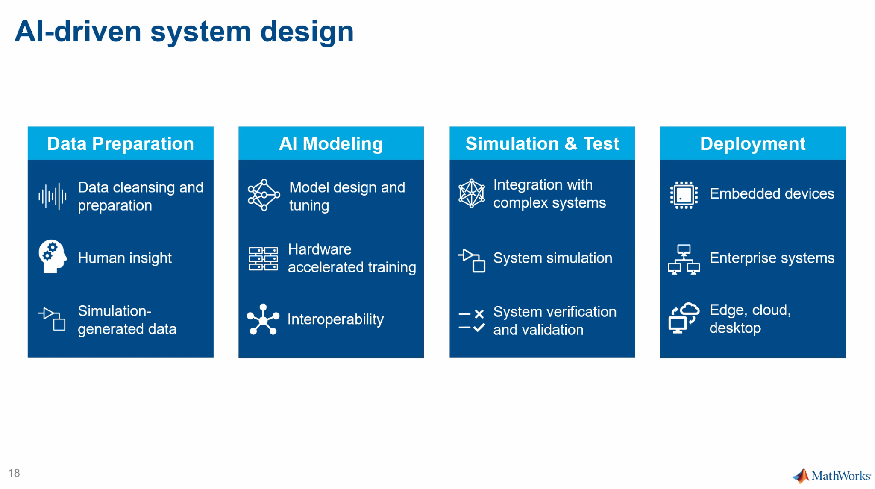

# MEETING NOTES

| **Discussion Topic** | **Notes** |
| --- | --- |
| Meeting schedule (day of week, time of day, number of meetings, etc) | * Thursdays at 6:15-7:15pm   + 6:30pm or 7pm start time also works |
| Preferred communication methods | * Slack is best, Maria will try to respond within 48 hours |
| Project scope + timeline | * Phase 1 (aim to finish by october maker day)   + Detect pedestrians and/or cyclists in the data using nuScenes   + Images/Video and LIDAR * Phase 2 (deadline flexible based on when we finish phase 1)   + Detect pedestrians and/or cyclists in the data using the dataset from a simulated environment   + Automated Driving toolbox scenarios   + (Maria hopes this phase will go by relatively quickly) * Phase 3 (aim to finish by November)   + Label safe and unsafe situations using images     - Retrain the DL model on the data we select from first 2 phases * Phase 4 (optional if time)   + Using video and LIDAR data incorporate a tracking algorithm to detect potential unsafe intent from a pedestrian and/or cyclist * Presentation in December   + Maria hopes to have us present at the MathWorks HQ |
| Dataset | * Option 1: real data   + E.g. nuScenes   + Real data involves sensor data from multiple sources   + Sensor data from:     - Camera     - LIDAR - similar to echolocation     - Radar     - IMU - inertial motion units     - GPS   + Challenge with data:     - What type of data source to use?     - Images or videos?       * Videos give more info about the intent of objects moving around     - Besides images, is there anything else that is helpful?   + Cameras and LIDAR are most popular, so Maria suggests using these     - LIDAR gives much more context to the scene   + The nuScenes dataset is really clean. Like almost too clean * Option 2: simulated data   + Usually you only use this if there is not enough real data   + We can think about doing this later, but we’ll work with real data for now * Will later discuss how much data we need |
| Deep learning | * Deep learning techniques are more specialized than ML * We will talk about and work with neural networks * Deep neural networks have several layers   + Input layer, hidden layers, output layer * Transfer learning * We will be building on things that are already available * Preprocessing data is very important bc network is as good as your data * Deep learning can be used to::   + Automate labeling   + Training an object detector using transfer learning   + Simulate within a larger system   + Deploy against live video * AI-driven system design   + Data prep     - Data cleansing and preparation     - Human insight     - Simulation-generated data   + AI modeling     - Model design and tuning     - Hardware accelerated training     - interoperability   + Simulation and test     - Integration with complex systems     - System simulation     - System verification and validation   + Deployment     - Embedded devices     - Enterprise systems     - Edge, cloud, desktop     - Bringing the model to hardware * Maria suggests getting acquainted with deep learning with TensorFlow |
| MATLAB | * Python will be our main language for the project * Get acquainted with TensorFlow * Maria suggests seeing MATLAB not as a programming language, but as the engineering environment * If we don’t have access to MATLAB, let Maria know * Maria will show us how to use MATLAB in a future meeting |
| Advice | * Maria suggests looking at YOLO v2 (you only look once)   + Real time object detector   + Already existing model that we can specialize for our purposes * Deep learning sounds really hard, but everyone is doing it so there are a lot of resources |
| Suggested next steps | * Look at the annotations in the nuScenes dataset * Play with TensorFlow tutorials so that we feel comfortable with deep learning * Determine how much data is needed to be able to train the model * Play with LIDAR data - there are Colab tutorials |

# ACTION ITEMS

| **Task/Assignment** | **Team Member** | **Deadline** |
| --- | --- | --- |
| Send slides from the meeting | Maria |  |
| Make sure you have access to MATLAB. If not, let Maria know | All |  |
| Look at the annotations in the nuScenes dataset | All |  |
| Play with YOLO v2 (you only look once), Resnet50 | All |  |
| Play with TensorFlow tutorials so that we feel comfortable with deep learning | All  Maria will send tutorials |  |
| Determine how much data is needed to be able to train the model | All |  |
| Play with LIDAR data - there are Colab tutorials | All |  |

Tentative action items (to be discussed with team later):

* TensorFlow - follow tutorial to classify images (?)
* Yolo v2 - play with it
* Resnet50
* Learn deep learning techniques/theory